1). Welcome page with Id and Password:-

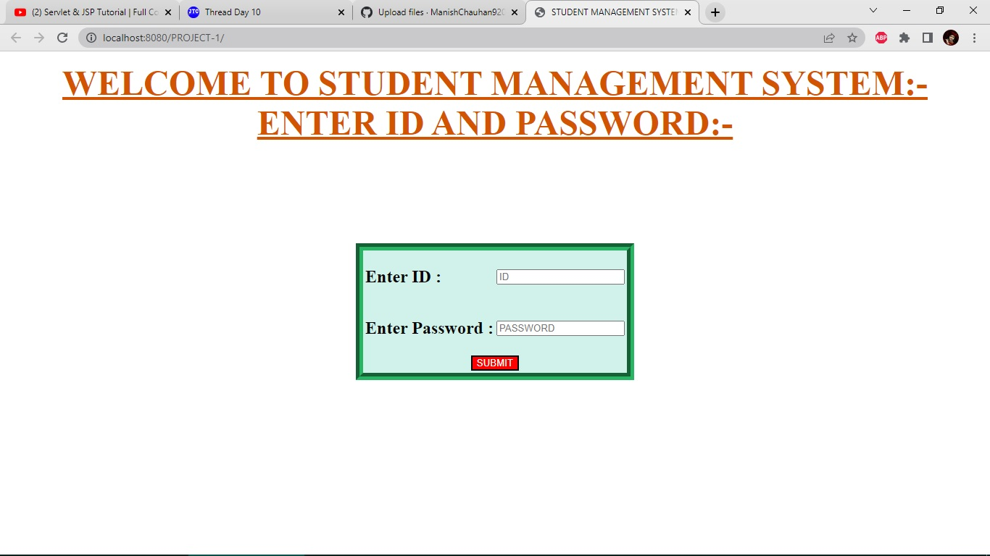

2). Page after wrong id and password:-

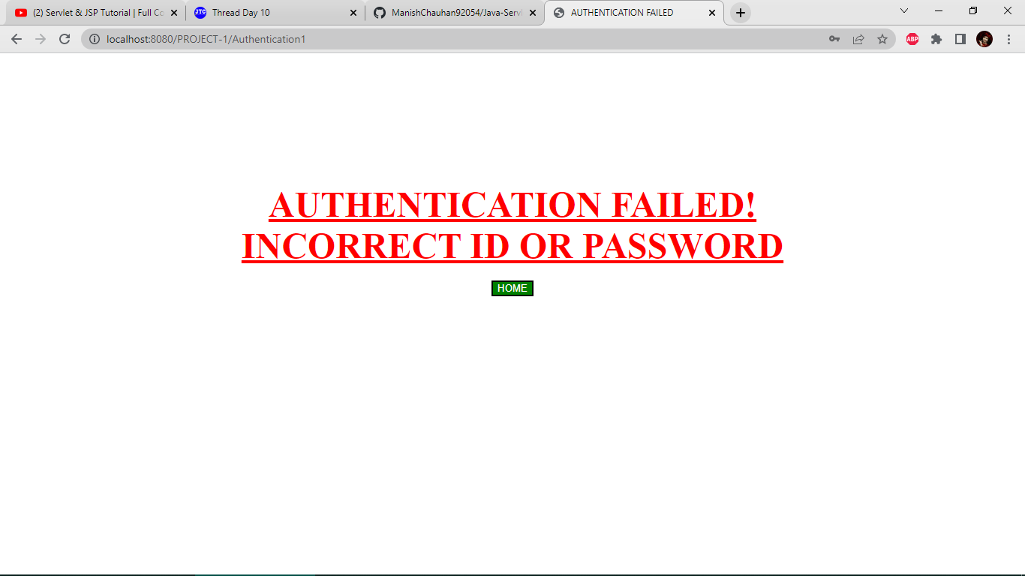

3). Main page after successful login with different options:-

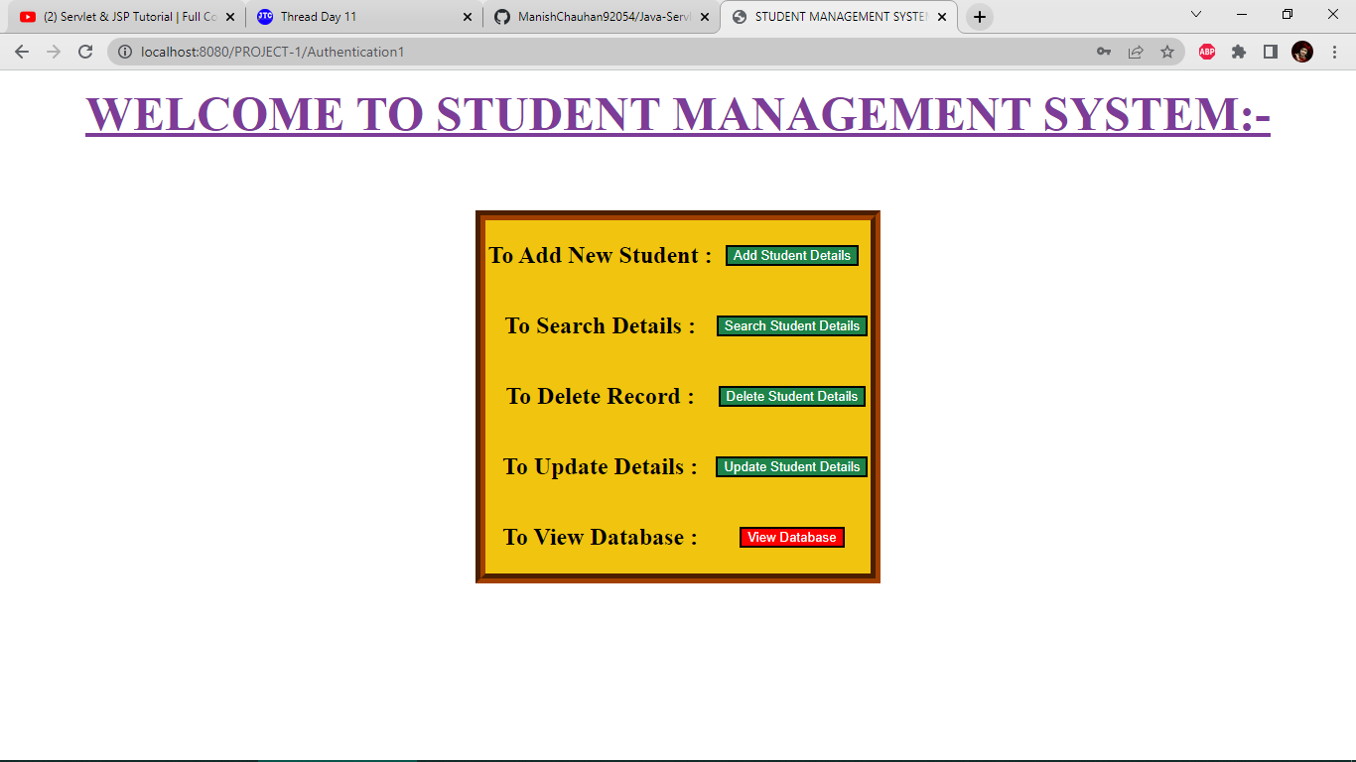

4). Adding new student with multiple details:-

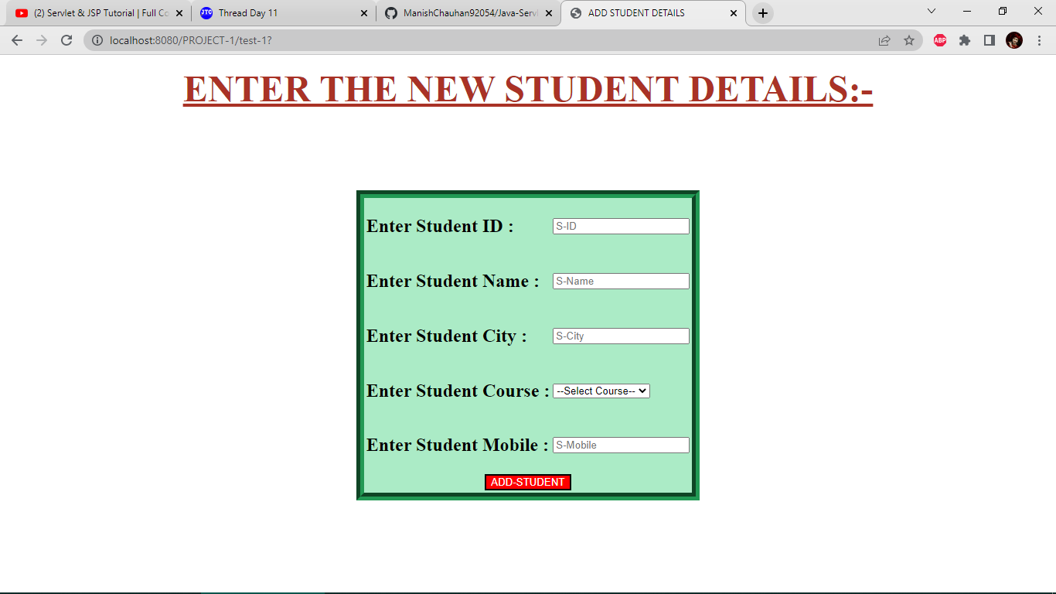

5). New student added successfully:-

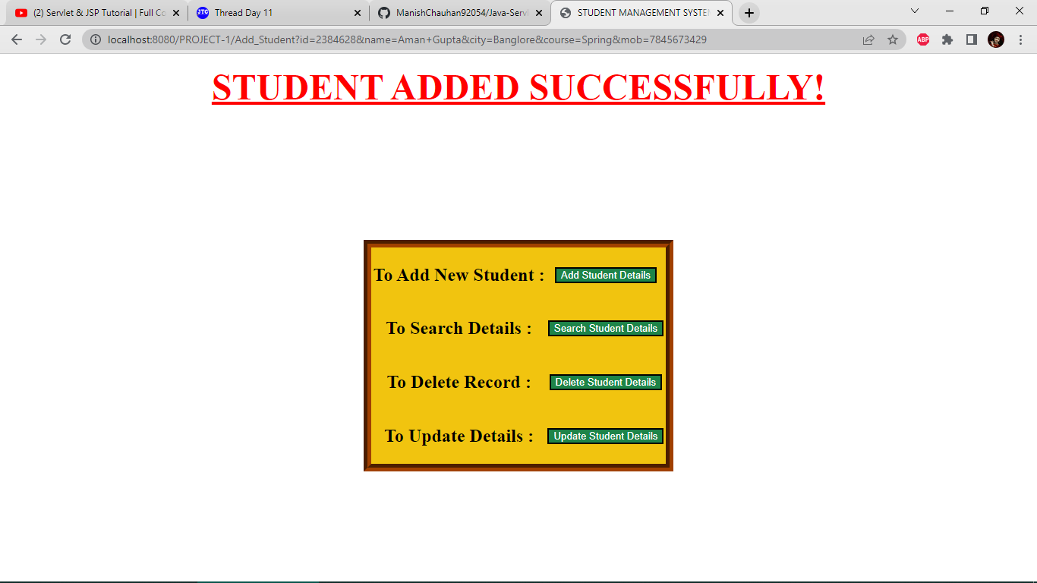

6). Search student details by id,name or mobile:-

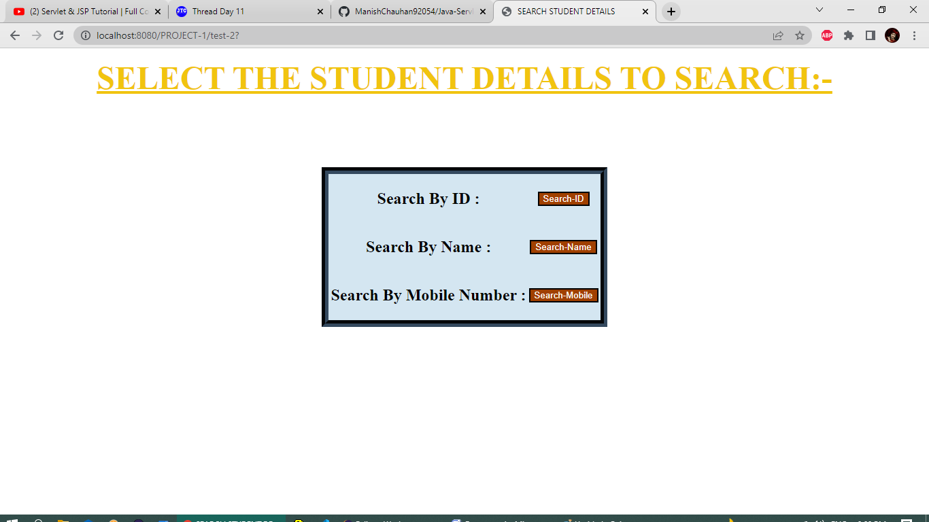

7). Search student by id:-

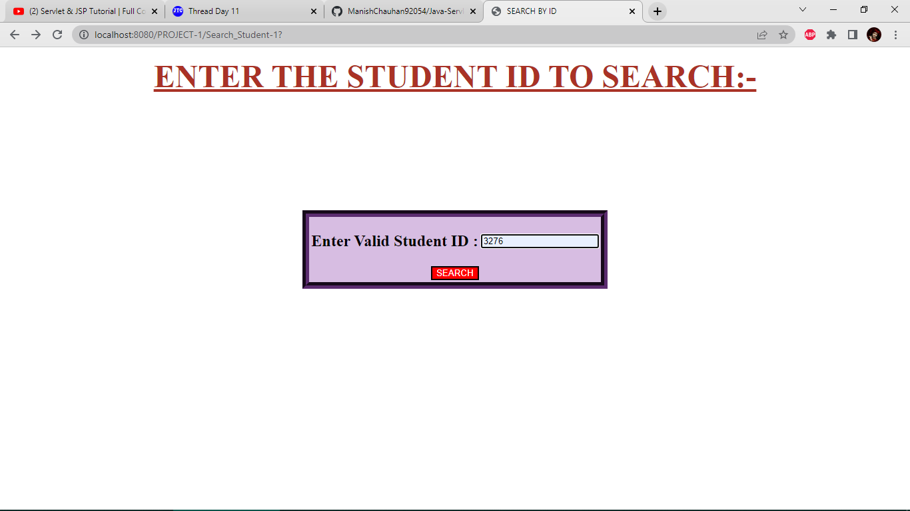

8).Records fetched after matching id in mysql database:-

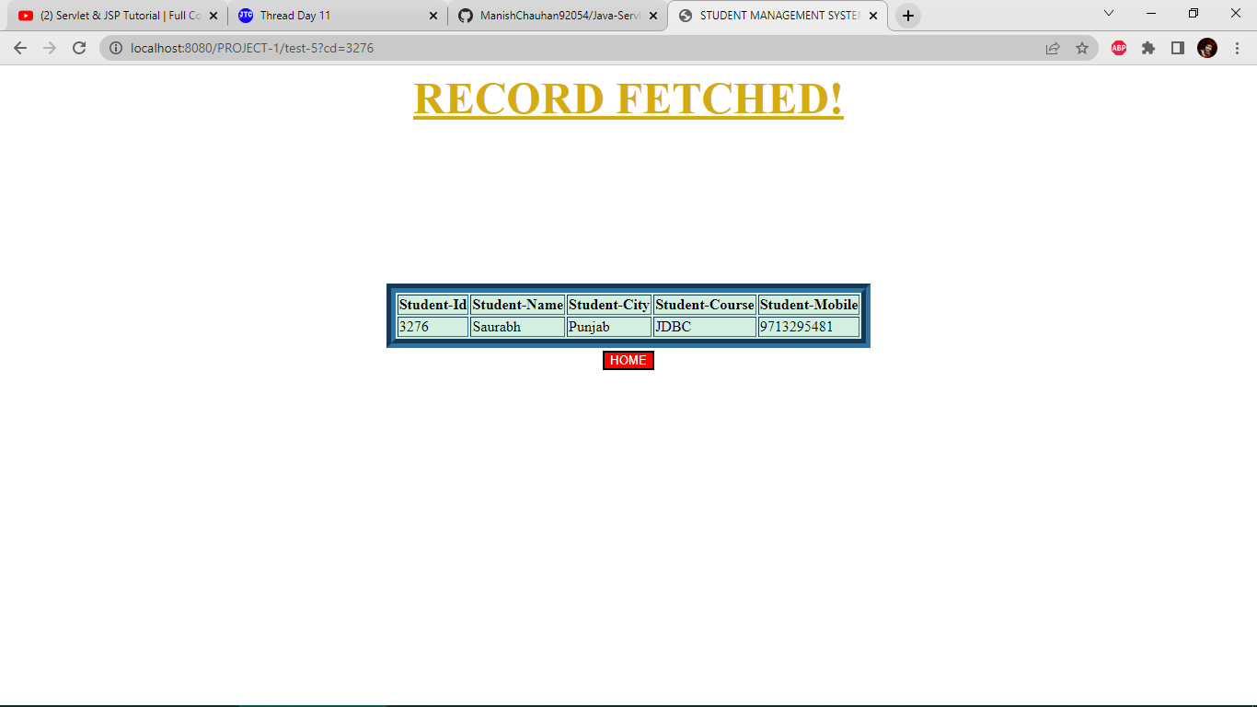

9). Search student by name:-

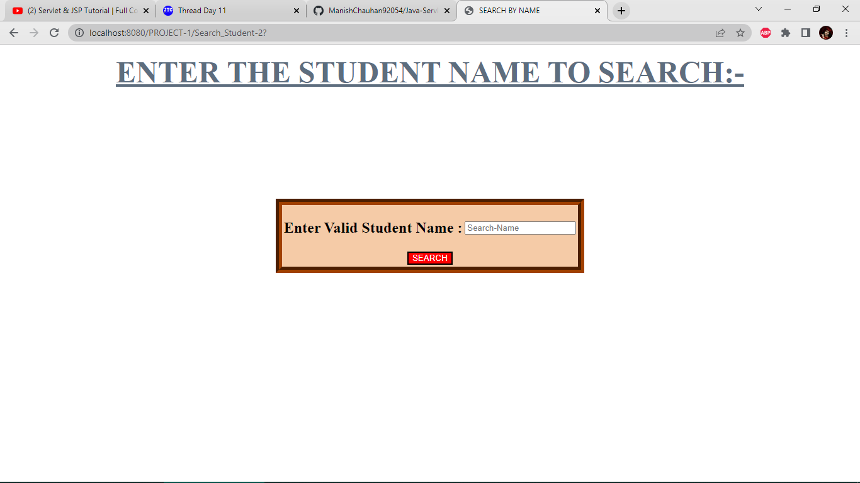

10). Records fetched after matching name in mysql database:-

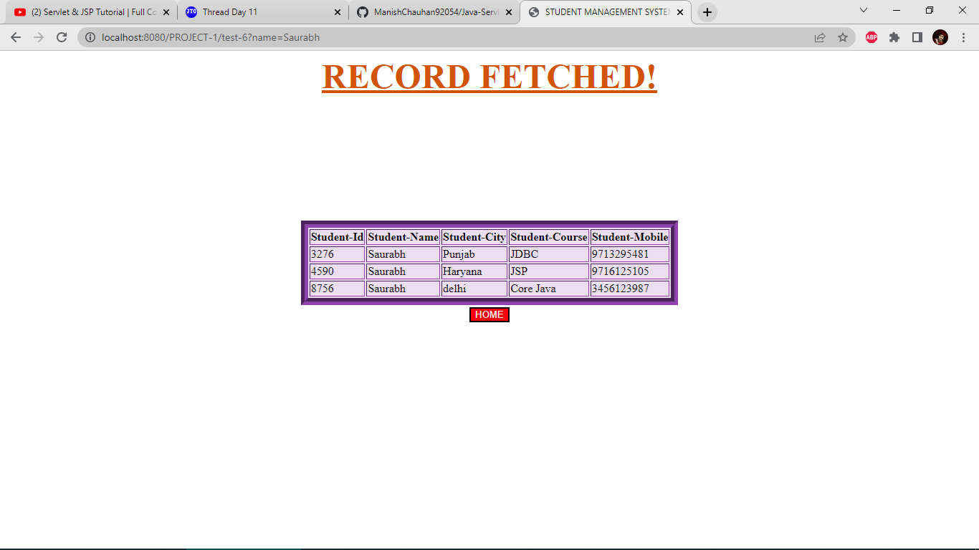

11). Record not found message if data is not found in database:-

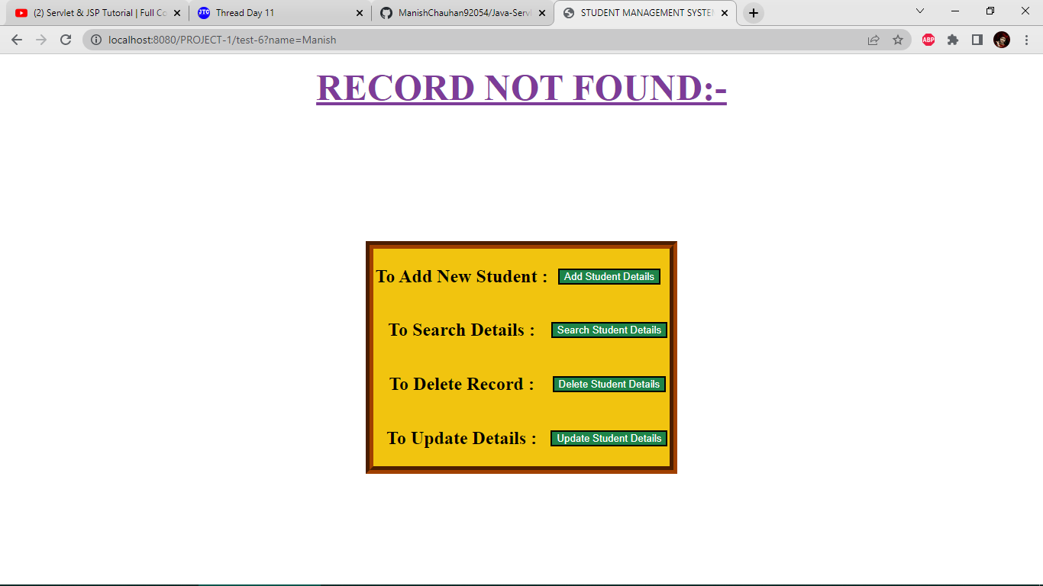

12). Search student by mobile:-

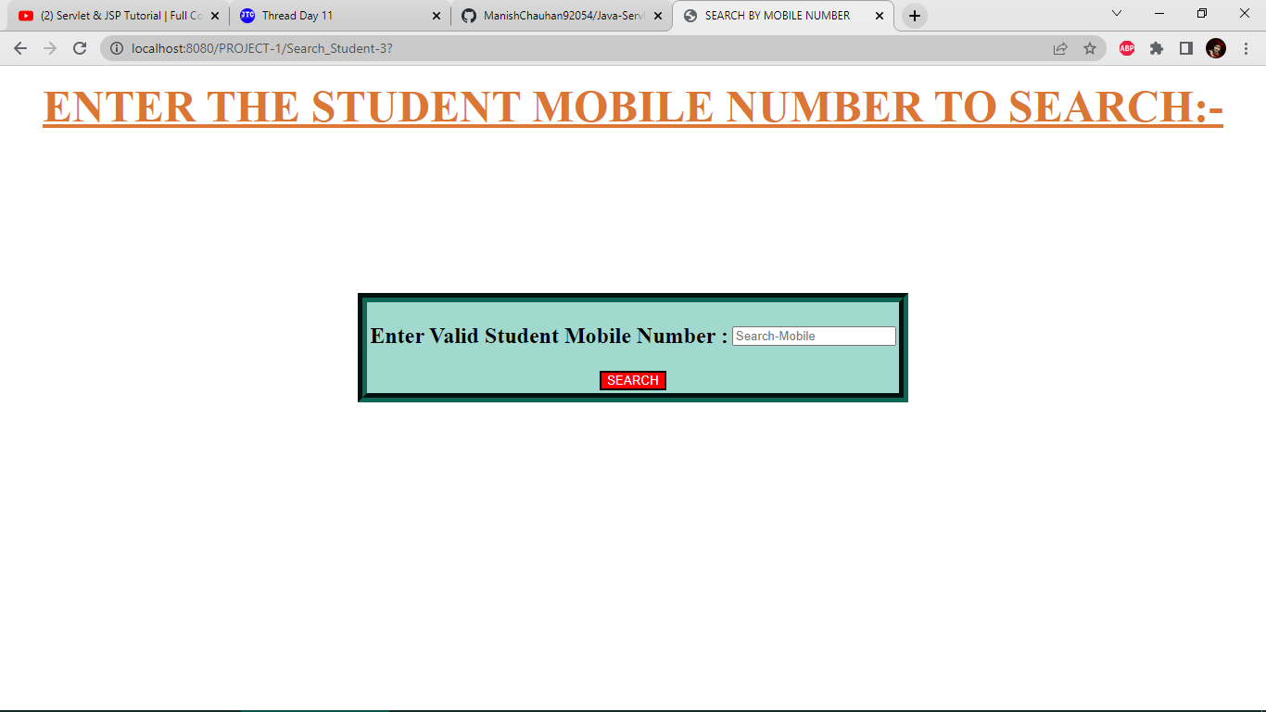

13).Record fetched after matching mobile in mysql database:-

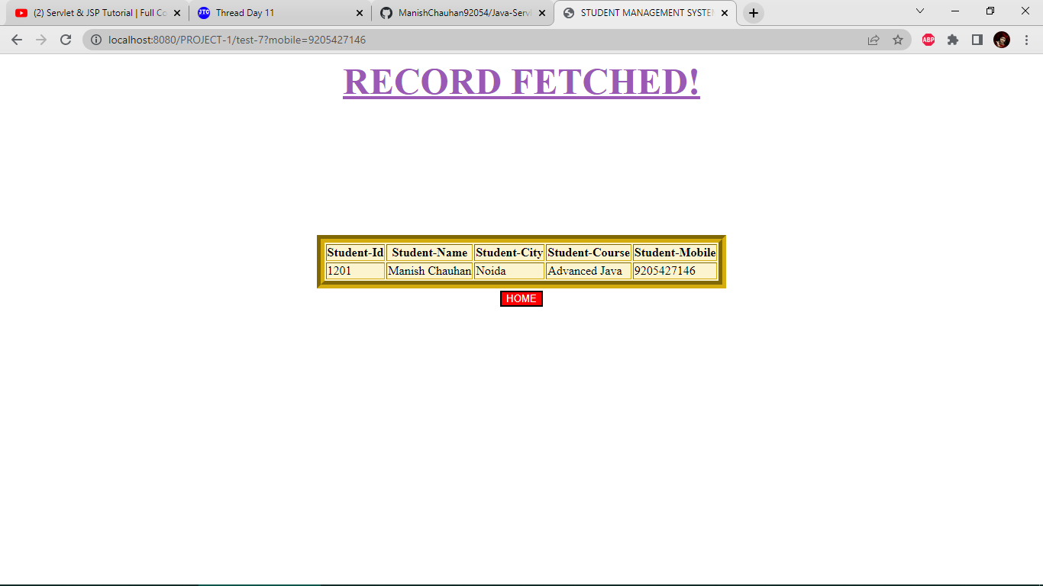

14).Deleting a student with unique id:-

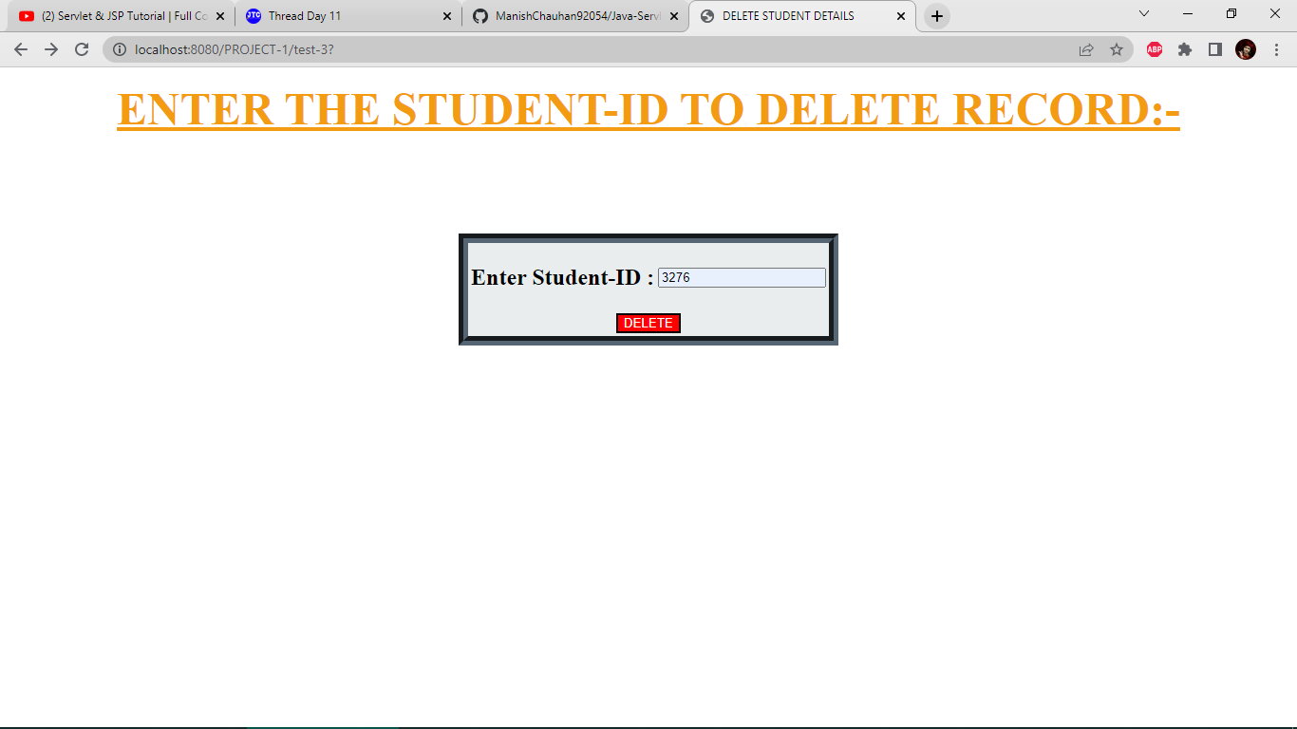

15).Record deleted successfully from database:-

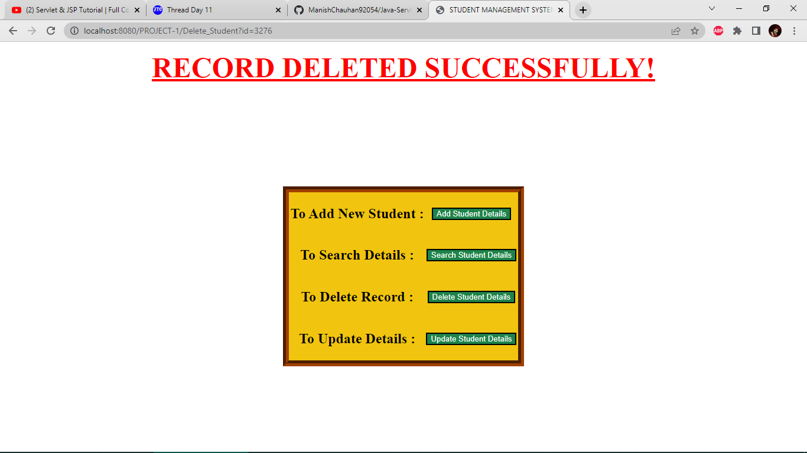

16). Update student details like name,city,course or mobile:-

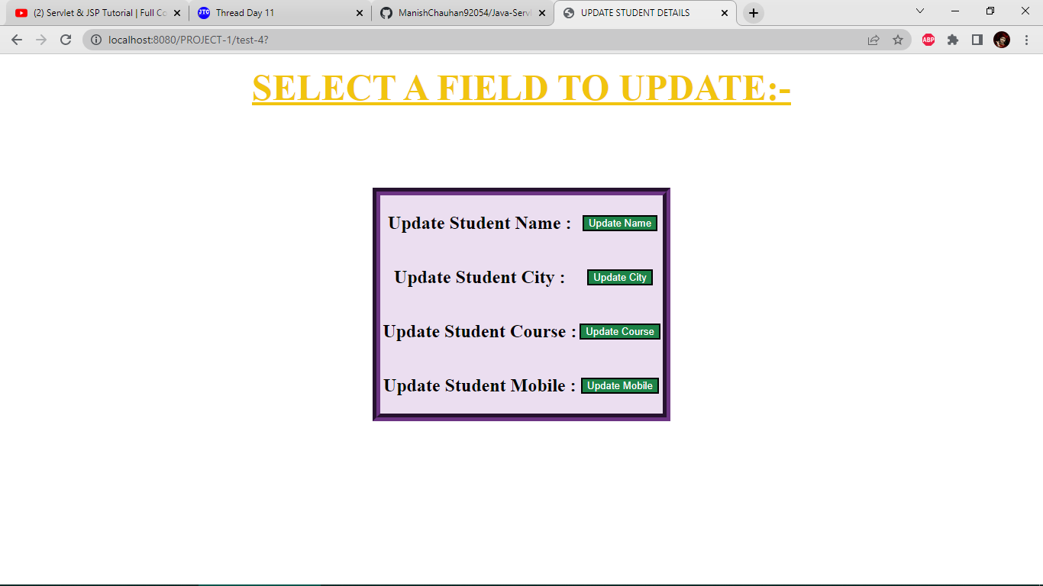

17). Asking for student id to update corresponding name:-

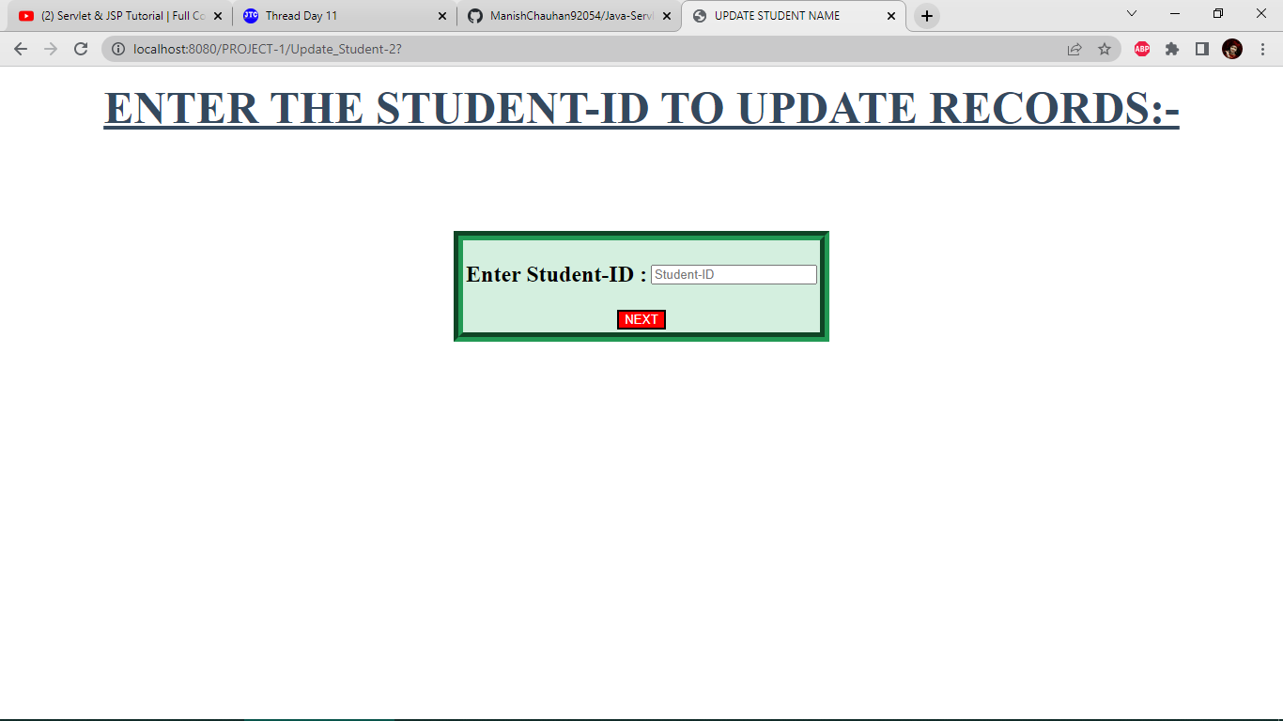

18). Updating name of a student:-

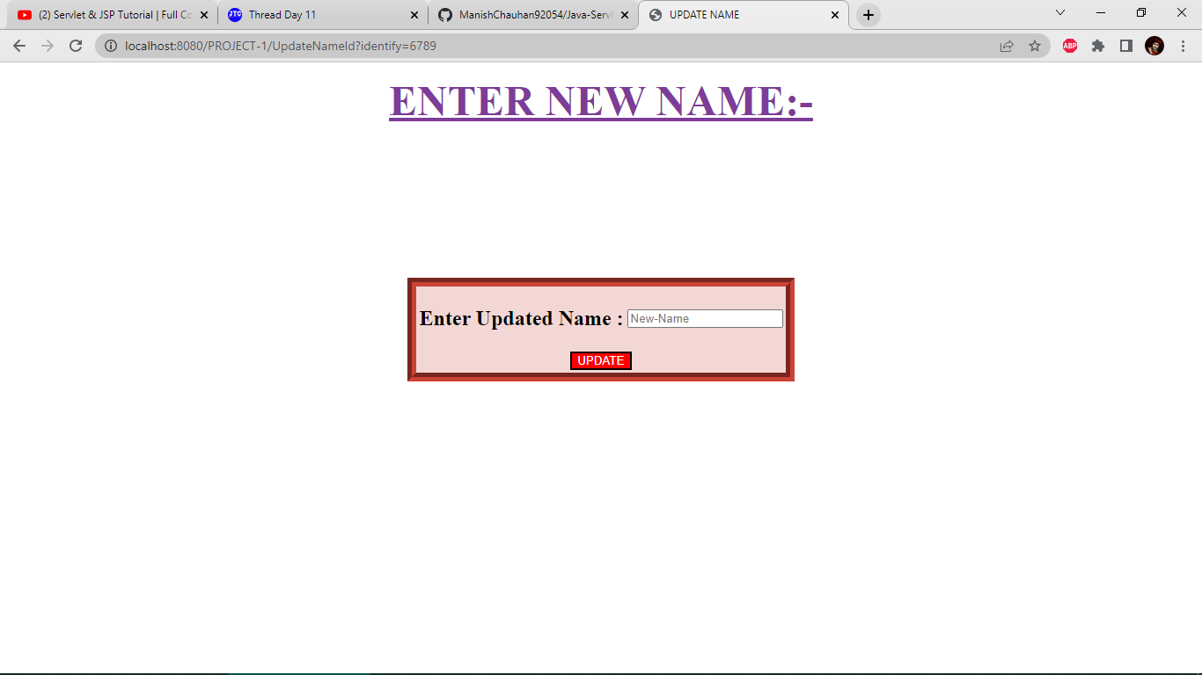

19).Name updated successfully:-

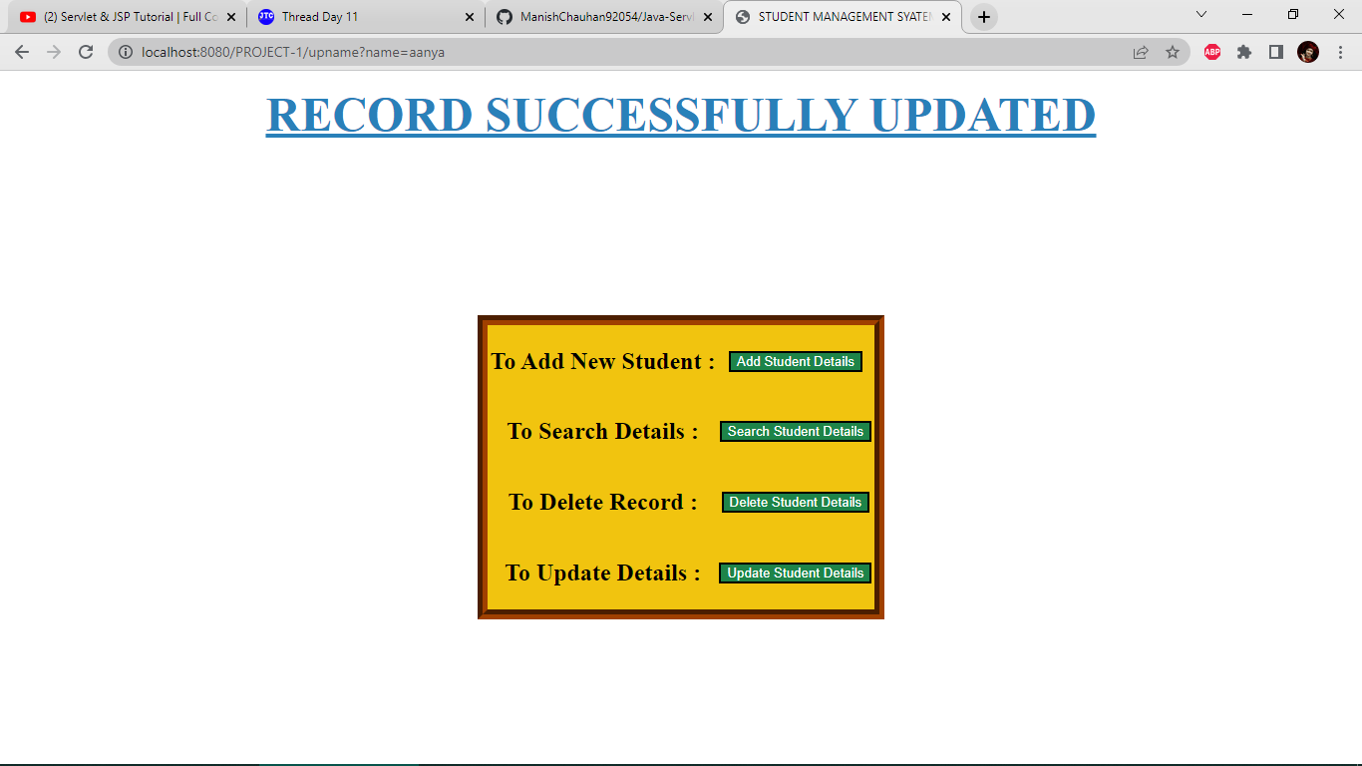

20).Updating city of a student:-

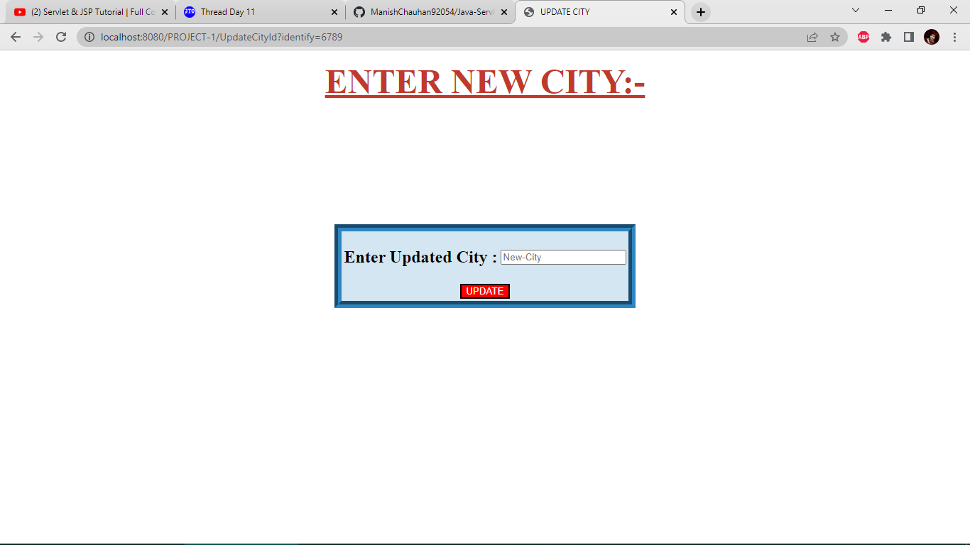

21). City updated successfully:-

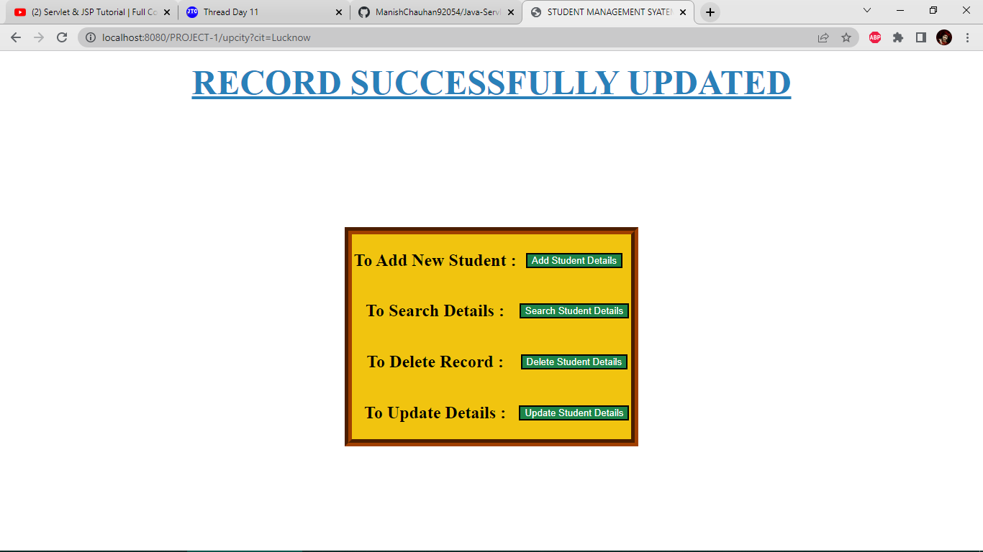

22). Updating course of a student:-

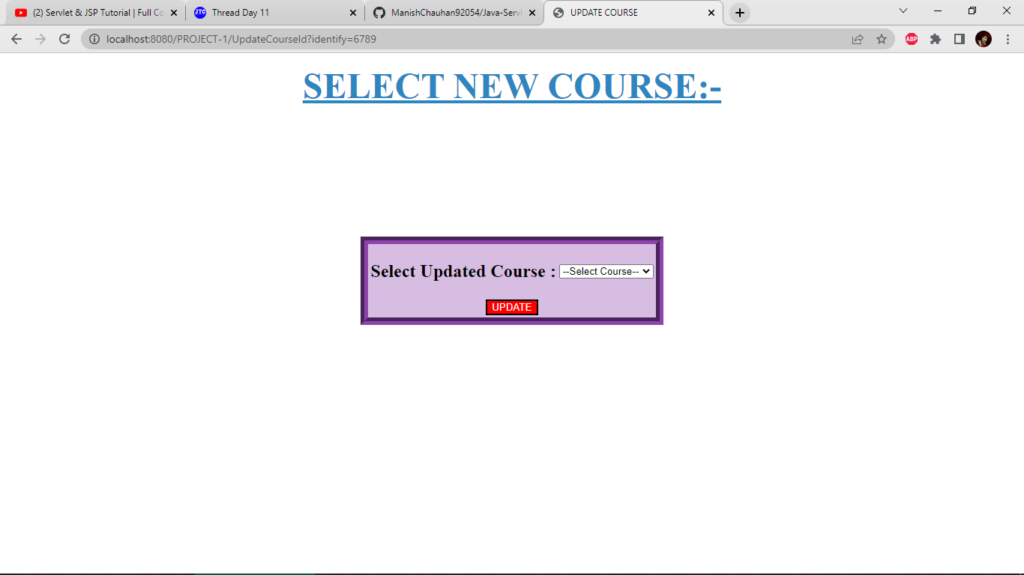

23). Course updated successfully:-



24). Updating mobile number of a student:-

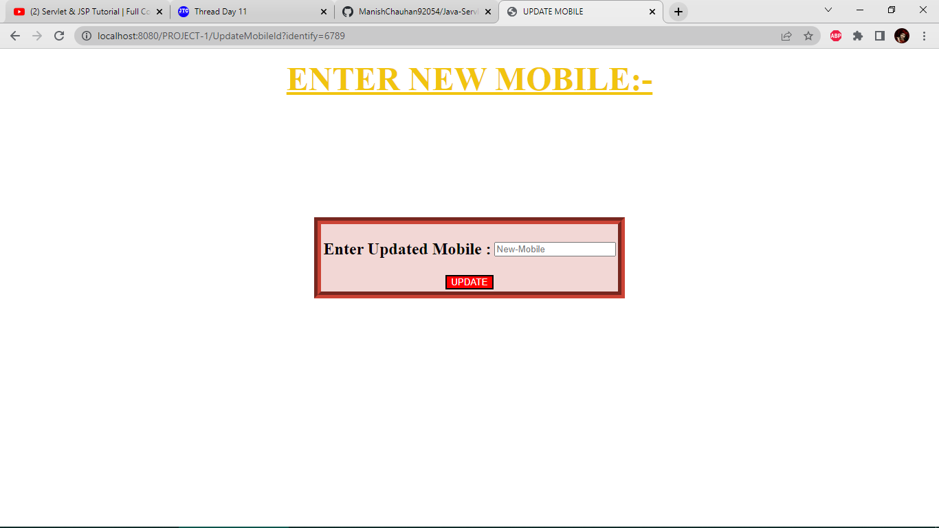

25). Mobile number updated successfully:-



26).Using ‘View Database’ button to take a look of entire database:-

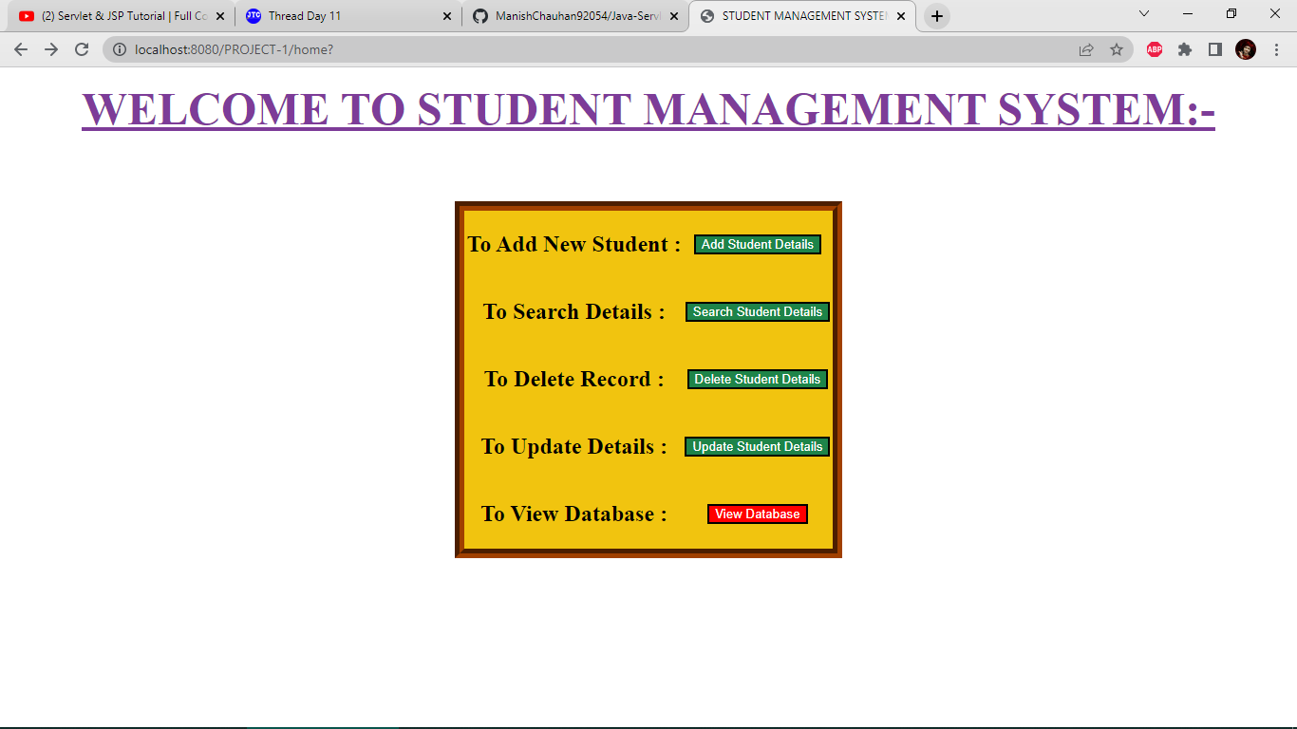

27). Asking for Id and Password for entering into database:-

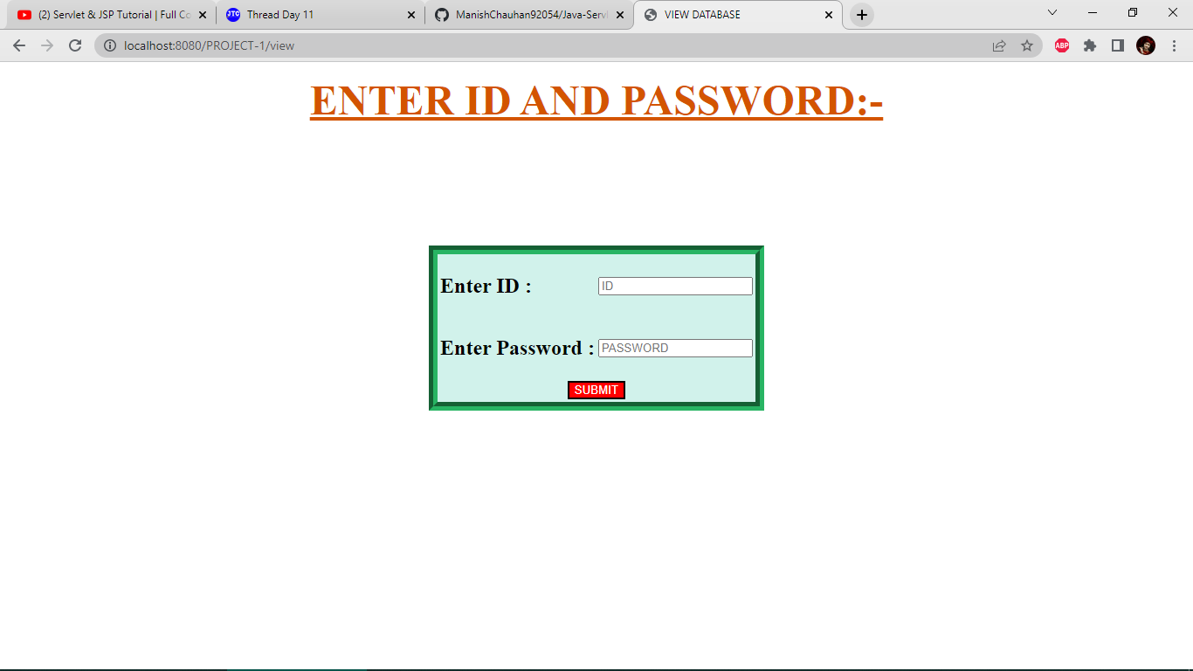

28). Entering wrong id and password for testing:-

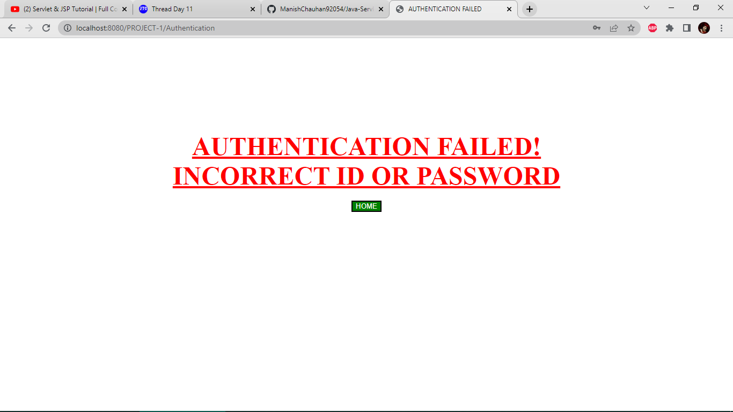

29). Fetched entire database after entering correct id and password:-

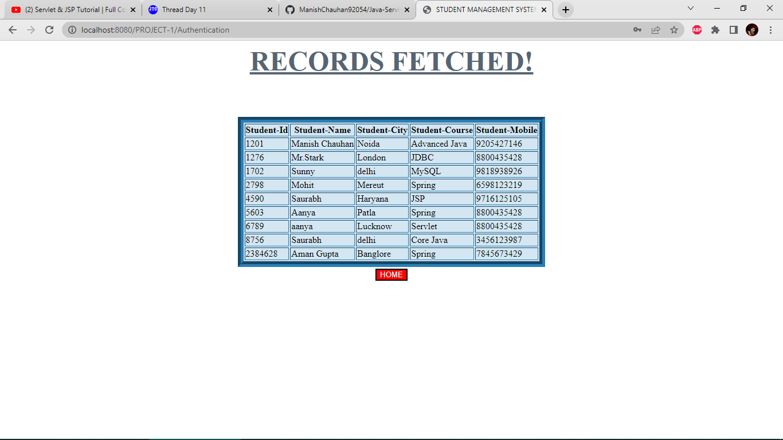

***THANK YOU FOR GIVING YOUR TIME TO MY PROJECT***